Practical - 4

Aim:
Implement a function of Sequential Search & Binary Search and count the steps executed by function on various inputs for best case and worst case. Also write complexity in each case and draw a comparative chart.

Code:

#include <stdio.h>
#include <stdlib.h>

int count_linear_search = 0;
int count_binary_search = 0;

int binary_search(int arr[], int size, int target) {
int left = 0;
int right = size - 1;

while (left <= right) {
count_binary_search++;
int mid = left + (right - left) / 2;

if (arr[mid] == target) {
return mid; // Target found at index mid
}
if (arr[mid] < target) {
left = mid + 1; // Search in the right half
} else {
right = mid - 1; // Search in the left half
}
}
return -1; // Target not found
}

int linear_search(int arr[], int size, int target) {
for (int i = 0; i < size; i++) {
count_linear_search++;
if (arr[i] == target) {
return i; // Target found at index i
}
}
return -1; // Target not found
}

int main() {
FILE *fp;
fp = fopen("arr.txt", "r");
int size = 0;
int target = 0;

fscanf(fp, "%d", &size);
fscanf(fp, "%d", &target);

int* array = (int*)malloc(size * sizeof(int));
for (int i = 0; i < size; i++) {
fscanf(fp, "%d", &array[i]);
}
fclose(fp);
// Linear Search
int result = linear_search(array, size, target);
if (result != -1) {
printf("Linear Search: Element found at index %d\n", result);
} else {
printf("Linear Search: Element not found\n");
}
printf("Size of Array used for Binary Search: %d\n", size);
printf("Number of Steps in Linear Search: %d\n", count_linear_search);
free(array);

// Binary Search
fp = fopen("arr_sorted.txt", "r");

fscanf(fp, "%d", &size);
fscanf(fp, "%d", &target);

array = (int*)malloc(size * sizeof(int));
for (int i = 0; i < size; i++) {
fscanf(fp, "%d", &array[i]);
}
fclose(fp);
result = binary_search(array, size, target);
if (result != -1) {
printf("\nBinary Search: Element found at index %d\n", result);
} else {
printf("\nBinary Search: Element not found\n");
}
printf("Size of Array used for Binary Search: %d\n", size);
printf("Number of Steps in Binary Search: %d\n", count_binary_search);
free(array);
return 0;
}

Output:
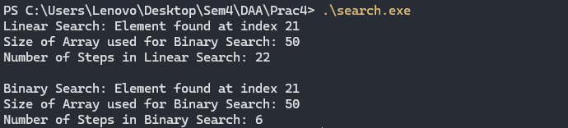

Analysis:

Value of N | Index Of Key | Steps in Linear Search | Steps in Binary Search
5 | 3 | 4 | 2
10 | 4 | 5 | 1
20 | 8 | 9 | 5
30 | 17 | 18 | 5
40 | 26 | 27 | 4
50 | 21 | 22 | 6

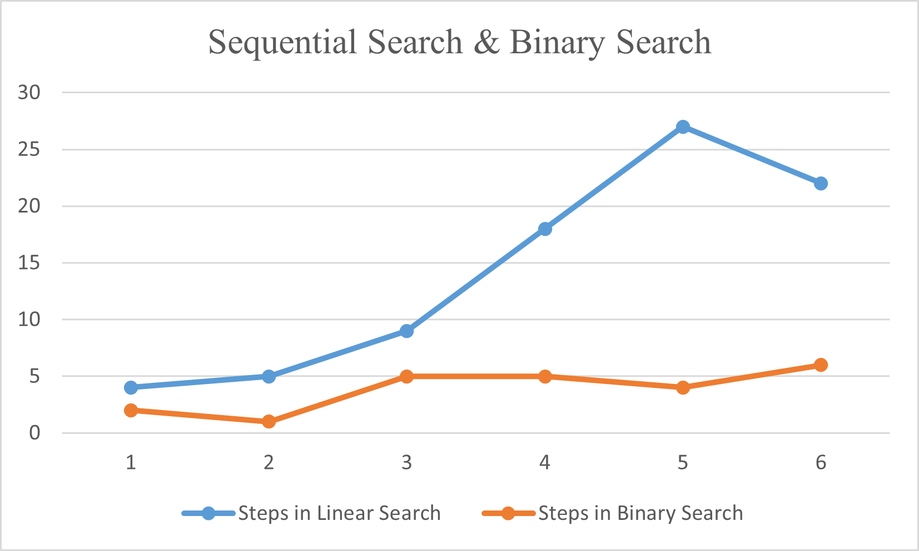

Conclusion:
- The program contrasts Sequential Search & Binary Search.
- The Sequential Search approach runs in O(n) time with O(1) space, comparing every index in Sequence.
- The Binary Search approach runs in O(n logn) time with O(1) space, Discarding half array every comparison.
- The Binary Search approach need sorted array to work.
- Step counts clearly show the Binary Search scales efficiently then Sequential Search.
- From this we can conclude if our data is sorted then using Binary Search is always better. Else Sequential Search is used for unsorted data.

